The genealogic tree of the 16 known Giulietta Sprint Veloce Zagato
The SVZ number 4458 is the 5th, 1957 with double buddle

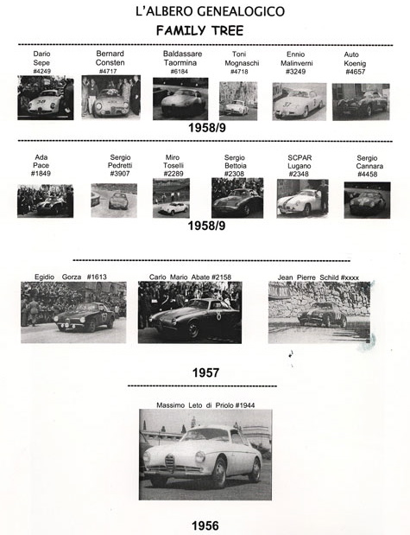

Documented Races of the Giulietta SVZ # 4458
1) July 6, 1957; Race: Castel d'Acque – Venasca raced by Sergio Cannara prior to the Zagato rebodying' placing unknown;
2) May 24, 1959; Race: Castellarquato - Vernasca; SVZ $ 4458 raced by Sergio Cannara; 1-st place;
3) Giugne 30, 1959; Race: Predappio - Rocca delle Camminate; SVZ $ 4458 racxed by Sergio Cannara; 1-st place;
4) 4) July 26, 1959; Race: Trieste - Opicina; SVZ $ 4458 raced by Sergio Cannara; p[lacing unknown;
5) August 30, 1959, Race Corsa dei Colli Torinesi, SVZ # 4458 racxed by Cannara; 1-st place;
6) May 8, 1960; Race: Targa Florio; SVZ $ 4458 raced by Fernando Natella and Pietro Flordelisi; placing unknown;
7) July 3, 1960; Race: Targa Vesuvio; SVZ $ 4458 raced by Antonio Covino; 3-rd place;
8) August 28, 1960; Race: Selva Fasano; SVZ # 4458 raced by Antonio Covino; 1-st place;
9) August 15, Race: Pescara 4 hours; SVZ $ 4458 raced by Fernando Natella for the Scuderia Sette colli; 9-th place
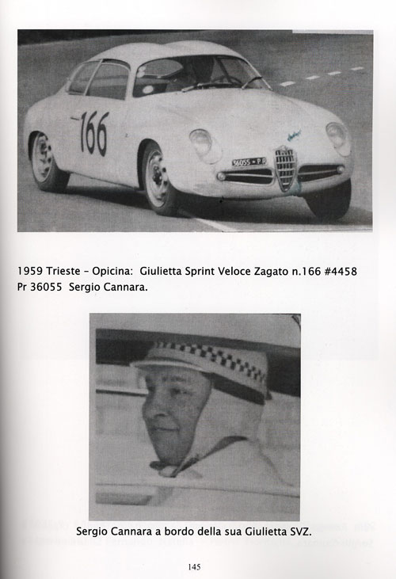

The Giulietta Sprint Veloce Zagato No. 4458 at the
Daytona Internbational race Track, October 2007

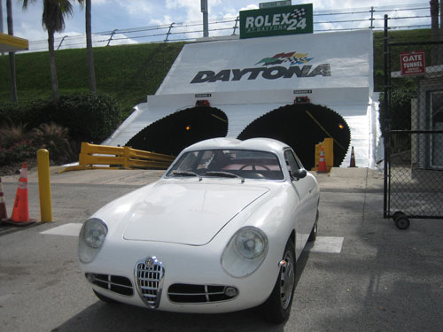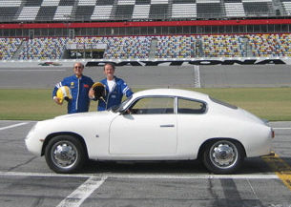

The Giulietta Sprint Veloce Zagato No. 4458 at the
Sebring International race Track, April 2010

